On The Irrawaddy to Coffee Land

(5) Days / (4) Nights Program
Period: November – March 2020
November 2019 – April 2020
Program Name: Ancient City & Magical Lake
Estimated Numbers of Pax: 2-20 pax
Proposed itinerary 2 (With Cruise)
(Actual itinerary can be changed depending on the available flight time)

Note: Ayratava Cruises and Irrawaddy Voyages, members of Interconnection Travels, are operating short cruises from Bagan-Mandalay-Bagan. But these are scheduled cruises which are being operated on some specific days as per schedule. For example, Bagan to Mandalay (2-night cruise) is operated on Tue & Fri. From Mandalay to Bagan (1-night) is operated on Thursday and Mandalay-Bagan (2-night) is operated only on Sun. Therefore, your travel date is needed to fit in the Cruise Schedule as follows:

Day 1(TUE) Mandalay-Pyin Oo Lwin (train) (- / - / - )

In the early morning (about 4.30 hrs), take a train to Pyin Oo Lwin. Upon arrival at Pyin Oo Lwin, visit local coffee shop and get over your jetlag with a fine pour-over!

Linger across Kandawgyi National Gardens and immerse into the Myanmar nature and culture.

Join us at Ngu Shweli Coffee Farm for a unique ride on the pick-up and learn about coffee pickings in one of Pwin Oo Lwin’s most beautiful farms. Prepare for subtle flavors of natural dried coffee, almond, apple, citrus, caramel, dried fruits. The owner U Kyaw Sein will be happy to take you across his farm.

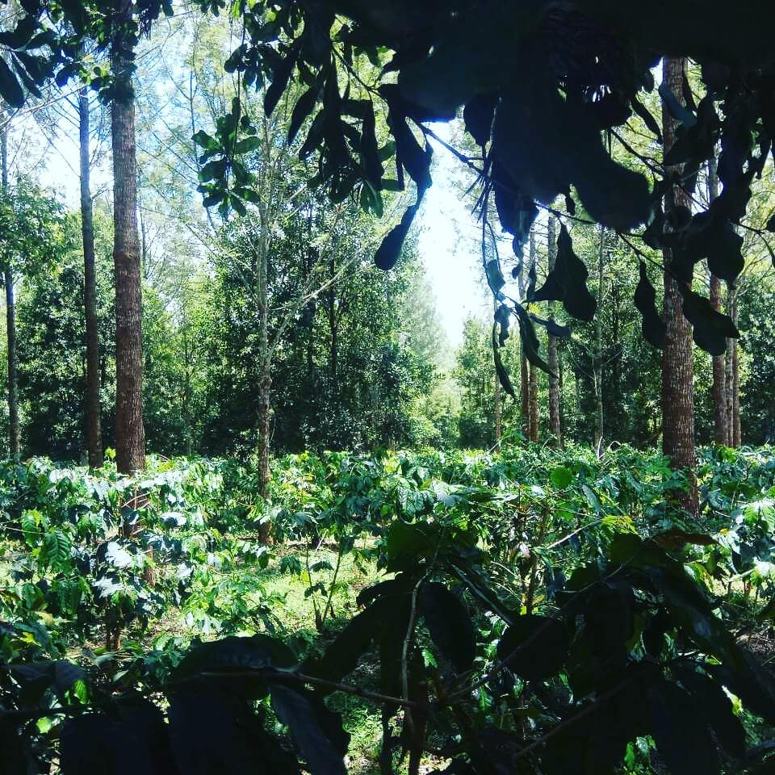

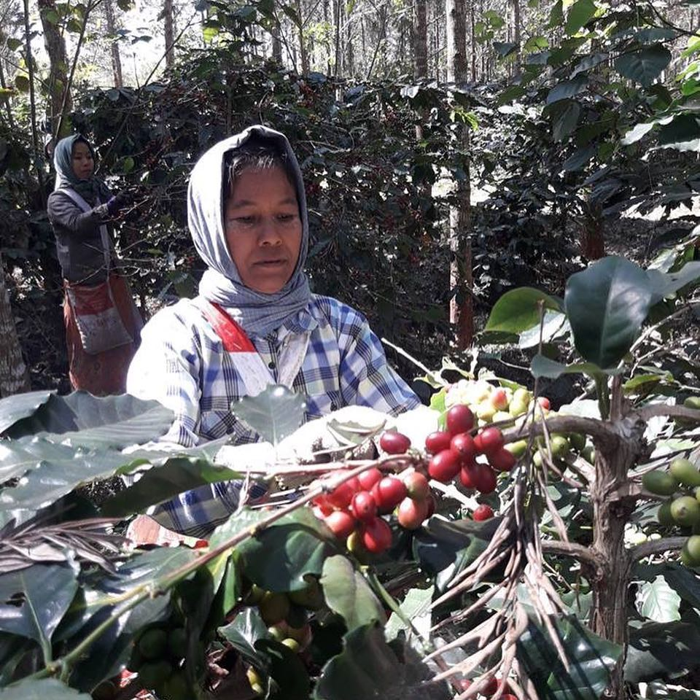

Day 02 (WED) Pyin Oo Lwin (Maymyo) ( B / - / - )

Delicious Myanmar and continental breakfast at the hotel. Visit two Coffee Estates and the mill MCG (Myanmar Coffee Group). Visit the patio, processing plants and warehouse.

The visit at MCG is followed by an amazing cupping of different estate coffees.

Learn about the different processing types and quality standards for exports. Meet the marketing director of MCG.

Overnight at Pyin Oo Lwin
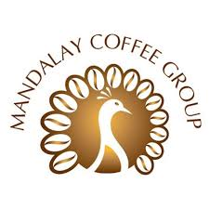

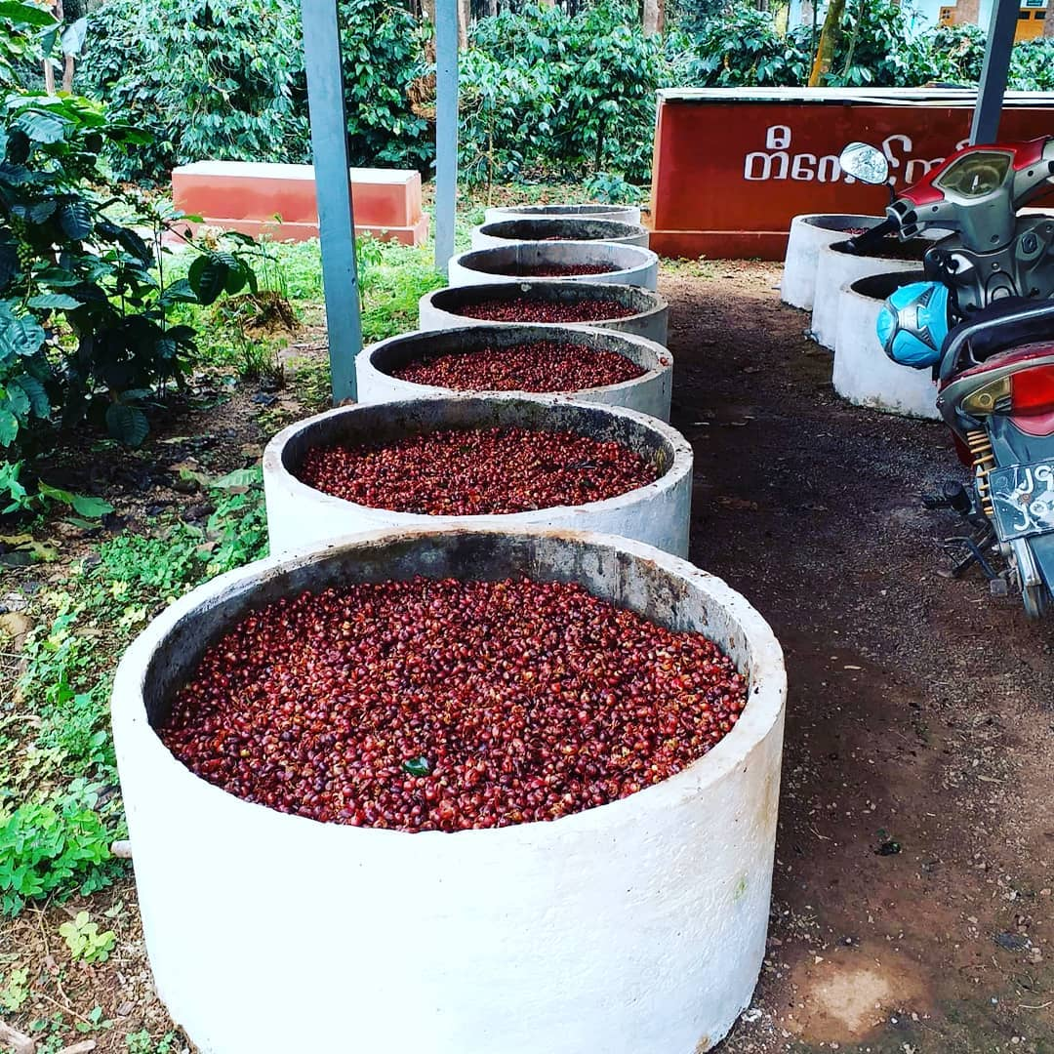

Day 03 (THURS) Pyin Oo Lwin-Mandalay-Bagan (Cruise)(1-night) ( B / L / D )

For early birds – brew your sunrise coffee at a peaceful pagoda side and enjoy breakfast at the hotel.  Drive to Mandalay.  Transfer to jetty to embark the Ayravata Cruise (www.ayravatacruises.com) to sail to Bagan along the Ayeyarwaddy river.  Overnight onboard.  Remark: There are FOUR CRUISES operated by Ayravata Cruises Co., Ltd and so the specific assigned and operated cruise will be announced when the actual operations draws near. (The photo shown is taken from one of those cruises) 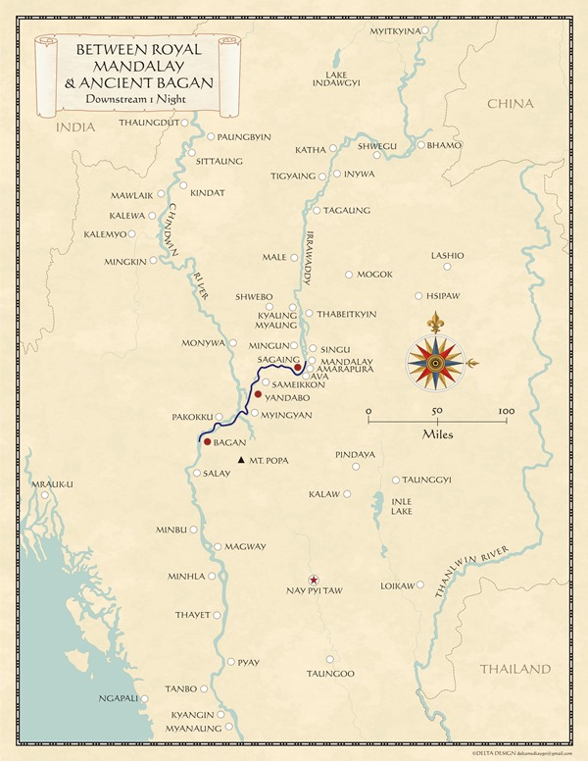 | 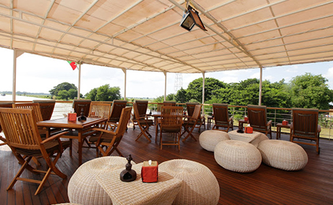  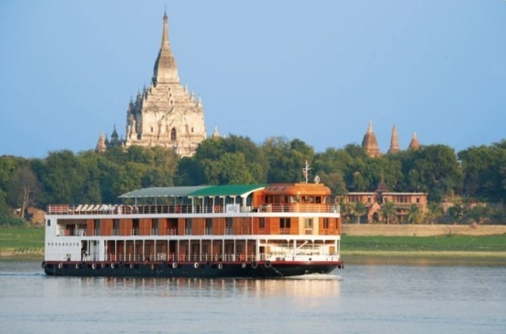

Day 04 (FRI) Disembark Bagan/ Sightseeing in Bagan (B / - / - )

Disembark cruise at Bagan. After disembarkation, sightseeing in Bagan, one of the Asia’s most popular archaeological destinations and one out of two most pre-eminent religious old cities in South East Asia. The sightseeing starts with a visit to NyaungOo market – a typical local market; followed by visits to most distinctive pagodas such as Shwezigon Pagoda – the holiest one believed to be enshrined with Buddha tooth and hair; Gubyaukgyi Temple (Wetkyiinn village) – the 13th century ‘cave temple’ with fine frescoes of scenes from Jakatas; Ananda Temple – one of the masterpieces surviving and remaining in Bagan and considered to be in the Mon architecture style.
Afternoon, we will visit a lacquer ware factory followed by a visit to local village. Overnight at Bagan.

Day 05 (SAT) Bagan-Yangon (flight) ( B / - / - )
Breakfast at the hotel. Transfer to airport to fly back to Yangon. Take a flight to Yangon.

*** End of Itinerary ***
No. of Pax | Cost in USD net per person
2 Pax +1 T.L | USD 1155 PER PERSON
3-4 Pax +1 T.L | USD 1023 PER PERSON
5-9 Pax +1 T.L | USD 875 PER PERSON
10-14 Pax+1 T.L | USD 795 PER PERSON
15-20 Pax+1 T.L (FOC) | USD 769 PER PERSON
Single Supplement | USD 400 PER PERSON
City
 | DELUXE (5*)
PWIN OO LWIN | HOTEL PYIN OO LWIN, SUITE ROOM OR SIMILAR
BAGAN | AUREUM PALACE RESORT, DELUXE ROOM OR SIMILAR
Validity: 01 Nov 2019 to 31 Mar 2020

Cost Terms
Cost includes | Cost excludes
Accommodation with daily breakfast in twin basis (Pyin Oo Lwin & Bagan) | Accommodation charges in Yangon
Ground transfer & transportation with A/C vehicle (24 Seaters) | Meals arrangement for all lunches & dinner during the trip except Cruise onboard
Excursion tour with entry fees at Pyin Oo Lwin & Bagan | Drinks & Beverages
Cruise Package cost for Mandalay-Bagan (1-night) | Early check in & Late checkout
2 domestic flight fare and airport tax for YGN – MDL-BGN – YGN | Insurance
Services of Local English Speaking Regional Guides in Mandalay & Bagan | Local English-speaking Guide service in Yangon
Train fare from Mandalay to Pyin Oo Lwin | International airfare & airport taxes
Airport transfer services in Yangon | Personal expenses & gratuity, Porter charges
 | Seasonal Supplements
 | Any other not mentioned in “Cost includes” section

Other costs
Extras, Supplements and Reductions
Category: Guide
Language speaking Local Guide | Supplement | Instead of using English speaking guide |  | USD 20 per day per group
Category: Meals
Venue | Type of Cost | For the Service of | Period | Cost
Local Restaurant (Chinese/ Myanmar Set Menu) | Supplement | Set Lunch OR Dinner without drinks and cultural show |  | USD 12 - 15 per person per set meal

Prepared by: (AZM/ 9 Aug 2019)

Please ensure that you have read, understood and accepted the following Terms and Conditions before submitting your booking. Once you make the booking – via online or signing our booking form or by phone or by email or any other form - you are deemed to have read, understood and accepted the following Terms and Conditions by yourself and on behalf of all the participant participating in and using the service of that booking.

Terms and Conditions

Booking Procedure
All bookings must be sent to and booked through Interconnection Travels offices by fax or e-mail or in person. Our travel consultants will assist you in organizing the itinerary or your travel arrangement(s) based on your interest and needs. Once the itinerary is fixed, our team will start the reservation of the services as per agreed itinerary.

The reservation status and confirmation are generally sent by return fax or e-mail within one working day. In case immediate confirmation is not possible, we will inform you of the booking status as soon as we can.

Deposit, payment and cancellation terms
A non-refundable deposit, 15% of total cost of a booking, is required to secure the booking at the time of the confirmation of the services
50% of total cost of a booking is required 91 - 81 days prior to the arrival for the confirmed allotment (Any booking later than 90 Days prior to arrival is subject to 50% of total cost as prepayment to secure the booking.)
The remaining balance is due 81 days prior to the arrival of the group to Myanmar
Bookings without deposit or prepayment cannot be regarded as confirmed booking and the services or confirmations could be dropped or changed at any time without notice.

All the payment must be settled by swift or telegraphic transfer to the bank account mentioned by Interconnection Travels together with the invoice and all the charges which are incurred by the banks must be borne by the payer.
Failure to settle the payment in time may be treated as a cancellation and below cancellation charges will be applied.
Cancellations must be sent by e-mail or fax to Interconnection Travels offices.

- 92 days or more prior to the start of the service: 15% of total cost of a booking
- 91 to 81 days prior to the start of the service: 50% of total booking price
- 81 to less than 81 days prior to the start of the service or no show: 100% of total tour package price

Remark:
Please take note that the above deposit, payment and cancellation terms are in general. Those general terms must be overruled by any more stricter or specific terms and conditions of the suppliers and also deposit, payment and cancellation terms must be changed as per the stricter or specific terms and conditions of the suppliers at the time of making the booking.

Refund or exchange of unused services
No Refunds or exchange can be made in respect of accommodation, meals, sightseeing tours, transports or any other services which are included in the tour prices but not utilized.

Tariff and Tour Prices
All prices quoted are on a net basis in United States Dollars and are valid in accordance with the date specified on our printed tariffs or quotation or confirmation via email or fax. Interconnection Travels make sure that the prices or rates quoted are correct at the time of issuance but we are holding the right to change it with or without prior notice in case of changes in the cost price due to unforeseen and out of control circumstances.

Services including the tariff or quotation are clearly stated. Interconnection Travels will not refund or exchange any unused services quoted in the tariffs or quotation.

Package tour prices are normally quoted based per person rate in twin sharing basis and for 15 fully paid passengers in the same group with the same itinerary, the sixteenth is complimentary unless otherwise it is not stated.

Infant and Child Policy:
Infant - Under 2 years and sharing the bed with parents: 40% of adult’s fare
Child - From 2 to 12 years old: 75% of adult's fare

Remark:
Infant and child policy as mentioned above are in general and applicable only for passengers taking the package tour.

Insurance
It is highly recommended that passengers buy full travel insurance covering medical evacuation, any form of loss or damage etc., before they start the trip from a reliable travel insurance company.

Responsibility & Liability
Interconnection Travels plans all the tours to the best of its ability as per agreement and takes the best care for the safety and satisfaction of passengers.

The passenger accepts that all tours are of an adventurous nature and involve an element of personal risk. Interconnection Travels, however, will not be responsible for and will not accept any liability for loss, personal injury or damage occurred during the tour. In case of such misadventure, Interconnection Travels would offer the every possible assistance to the passenger.

In case of any unexpected events/ circumstances such as flight delays, regional riots, natural disasters, etc., which are beyond control, Interconnection Travels has reserve the right to provide alternative accommodation or change the programs. However, we will endeavor to find the best possible alternatives in order to maintain the standard of quality of arrangements originally confirmed. Subsequent expenses must be borne by passengers.

Disclaimer
Interconnection Travels acts only as agent for acquiring travel and travel related services such as transportation, accommodation, sightseeing etc., on the express condition that Interconnection Travels shall not be responsible and liable for any loss, accident, injury, delay, defect, omission or irregularity which may occur or be occasioned, whether by reason of any act, negligence or default of any company or person engaged in or responsible for carrying out any of the arrangements, or otherwise in connection therewith.

Interconnection Travels shall not be responsible and liable for any injuries or any damage to any client or be subject to any claim, demand, injury, or damages, whatsoever, including without limitation, those damages from acts of passive or active negligence on the part of Interconnection Travels, its officers, employees, or agents. Client does hereby expressly release and discharge Interconnection Travels from all such claims, demands, injuries, damages, actions or causes of action. Client acknowledges that he/she has carefully read this paragraph and fully understands that this is a waiver and release of liability.

